EN Iteml No. 195H
User Manual
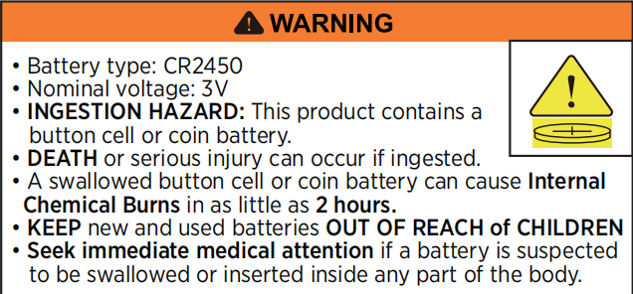
⚠ WARNING
• Battery type: CR2450
• Nominal voltage: 3V
• INGESTION HAZARD: This product contains a button cell or coin battery.
• DEATH or serious injury can occur if ingested.
• A swallowed button cell or coin battery can cause Internal Chemical Burns in as little as 2 hours.
• KEEP new and used batteries OUT OF REACH of CHILDREN.
• Seek immediate medical attention if a battery is suspected to be swallowed or inserted inside any part of the body.
a) Remove and immediately recycle or dispose of used batteries according to local regulations and keep away from children. DO NOT dispose of batteries in household trash or incinerate.
b) Even used batteries may cause severe injury or death.
c) Call a local poison control center for treatment information.
d) Non-rechargeable batteries are not to be recharged.
e) Do not force discharge, recharge, disassemble, heat above (manufacturer's specified temperature rating) or incinerate. Doing so may result in injury due to venting, leakage or explosion resulting in chemical burns.
f) Ensure the batteries are installed correctly according to polarity (+ and -).
g) Do not mix old and new batteries, different brands or types of batteries, such as alkaline, carbon-zinc, or rechargeable batteries.
h) Remove and immediately recycle or dispose of batteries from equipment not used for an extended period of time according to local regulations.
i) Always completely secure the battery compartment. If the battery compartment does not close securely, stop using the product, remove the batteries, and keep them away from children.

TECHNICAL DATA
Accuracy | ±1° (under typical sharpening conditions)
Resolution | 1°
Measurement Range | 0 - 80°
Battery | CR2450 3V (replaceable, 1 spare included)
Screwdriver | Included
Ingress Protection | IP54
Working Temperature | 32°F - 104°F (0°C - 40°C)
Note: This device is designed for use during actual sharpening rather than static measurement.

Under typical sharpening conditions, such as using an 8"x 3" ( 203 x 76 mm ) sharpening stone at a controlled speed (below 30 back-and-forth strokes per minute), angle fluctuation can be maintained within ±1°.

PRODUCT OVERVIEW
This Digital Sharpening Angle Trainer is designed as a sharpening training tool rather than a traditional precision measuring device.
It is intended for use during real sharpening movements to help users develop consistent hand control and muscle memory.
In sharpening, consistency is more important than absolute numerical precision. Maintaining a stable angle within ±1° typically produces better results than trying to hold an exact fixed reading.
For best stability, use on blades wider than 0.55 inch ( 14 mm ).
Blades narrower than 0.55 inch ( 14 mm ) may not provide sufficient contact area, which can affect stability and lead to less consistent readings.

SPEED RECOMMENDATION
When using an 8"x 3" ( 203 x 76 mm ) sharpening stone, keep the sharpening speed below 30 back-and-forth strokes per minute.
Slower and more controlled movement improves angle stability.
Faster movement increases hand-induced fluctuation and causes the reading to fluctuate more.
Focus on slow, steady, and consistent strokes.

UNDERSTANDING ANGLE READINGS
• This device shows real-time angle changes during sharpening.
• It does not lock or stabilize the reading like a static measuring tool.
• Slight variations are normal.
• The goal is to maintain a consistent range ( ±1° ), not a fixed number.

RECOMMENDED SHARPENING ANGLES
Type of Knife or Tool | Common Angle
Cleaver/Machete | 25 - 30 Degrees
Hunting/Pocket/Survival/Sport Knives | 20 - 25 Degrees
Chef's/Kitchen/Smaller/Boning/Carving Knives | 17 - 22 Degrees
Fillet/Paring/Sushi Knives/  Most Japanese Cutlery | 12 - 17 Degrees

FUNCTIONAL DIAGRAM
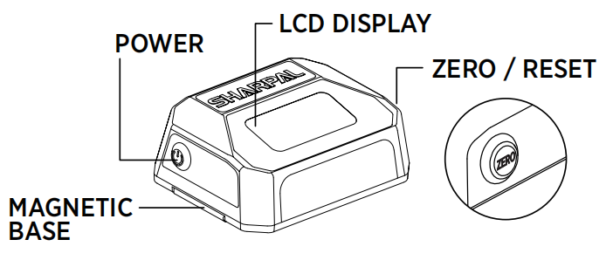
POWER
ZERO/RESET
LCD DISPLAY
MAGNETIC BASE

POWER ON / OFF
Power On: Press the power button to turn the unit on.
Power Off: Press and hold the power button for 1-2 seconds to turn the unit off.
Note: After powering on, the displayed angle may initially appear higher and then gradually decrease.
This is normal and indicates that the built-in sensor is performing automatic self-zero calibration.

INSTRUCTIONS FOR USE
- Place the device on the sharpening stone. Press the zero button and keep it stationary for about 2 - 3 seconds to calibrate. Lift the device and place it back on the stone to confirm that the reading returns to zero. If the reading does not return to zero, repeat the calibration process.
Note: Zeroing on the sharpening stone ensures accurate angle measurement between the blade and the stone.
As long as the sharpening stone position remains unchanged, repeated zeroing is not required during use.
- Attach the device magnetically to the upward-facing side of the knife blade, making sure it is held securely. Ensure the cutting edge is parallel to the long edge of the device, with the display facing the user directly for easy reading. ( See Fig.2-3)
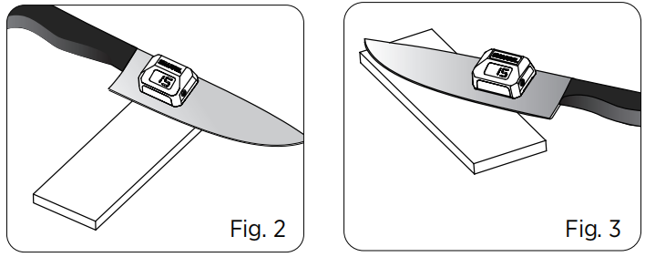
Note: The built-in gyroscope automatically accounts for blade geometry, so the displayed value is the sharpening angle. There is NO NEED to calculate or compensate for the spine angle separately. To sharpen at 20°, simply adjust the blade until the display reads 20°.
- Place the blade against the sharpening stone. Adjust the blade to the desired sharpening angle. (See Fig.2-3)
- Maintain a steady hand during sharpening and monitor the angle reading. If the angle deviates by more than 1°, slightly adjust the blade to return to the desired sharpening angle.
Note: Small fluctuations in the angle reading are normal. The device reflects real-time hand movement rather than filtering or averaging the data. Fluctuation usually indicates hand movement, not measurement error. Focus on maintaining steady motion instead of chasing a fixed number.

Tip: When sharpening the tip, the angle reading may change because the contact geometry changes as the blade curves. This is normal. Do not chase the changing number; continue following the same sharpening motion and angle previously set.

BATTERY REPLACEMENT
Replace the battery when the display becomes dim or difficult to read.
Only use a CR2450 (3V) coin cell. Do not use rechargeable batteries.
1. Turn off the device.
2. Remove the silicone pad.
3. Remove the battery cover using the screwdriver.
4. Replace with one CR2450 (3V) coin cell battery, positive (+) side facing outward.
Tip: Insert the battery by pressing it against the gold-colored contact first. ( See Fig.4)
5. Put the battery cover and silicone pad on.( See Fig.5)

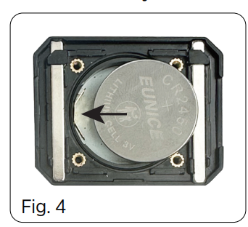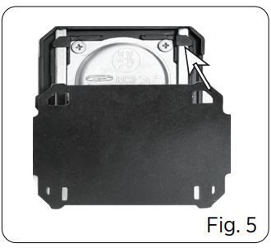

MAINTENANCE
- Wipe with a dry cloth. Use a slightly damp cloth to remove metal particles if necessary.
- If metal particles or sharpening residue accumulate on the silicone pad, remove it for cleaning. Rinse and dry completely before putting it back.
- Remove the battery if not used for an extended period.
- Store in a dry place. Avoid high temperatures and humidity.

MAGNET WARNING：This product contains magnets. Keep away from pacemakers, credit cards, mechanical watches, and other magnetically sensitive devices.

*Watch its demo video on YouTube:
Or scan QR code

*Each SHARPAL product is warranted to be free from defects in material and workmanship
for 3 years from the date of purchase under normal wear and tear, except for damage
caused by misuse or alteration. THIS WARRANTY APPLIES ONLY TO NON-INDUSTRIAL OR
NON-COMMERCIAL USE. If you want to make a warranty claim, please contact us through
the SHARPAL website or send an email directly to warranty@sharpal.com.

